Chapter 5, Problem 76

Solve Prob. 5.19 using PSpice and op amp uA741.

5.19 Determine i_{o} in the circuit of Fig. 5.57.
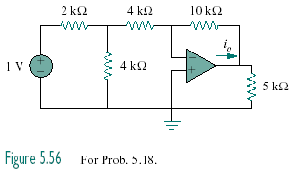
2 kΩ
750 mV

Figure 5.57
For Prob. 5.19 and 5.76.

